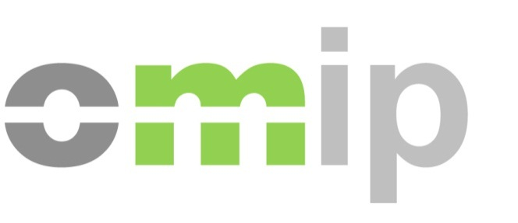
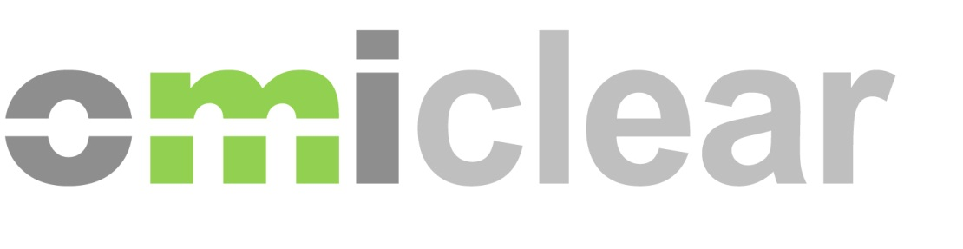
Iberian Energy Derivatives Market - Operational Training Course

Registration Form

Place: Madrid: OMIE headquarter - C/ Alfonso XI, nº. 6, Madrid
Date: 5th November, 2019
Language: Spoken in Spanish, Slides in Spanish
Time: 10:00 - 17:30
Price: 600 € (+ VAT)
After receiving the registration form dully filled, we will send an email with the invoice and payment instructions with bank details.

Participant:
Name
Company
E-mail

Invoice details:
Company
Address
Tax Number
Telephone Number
Contact Person

