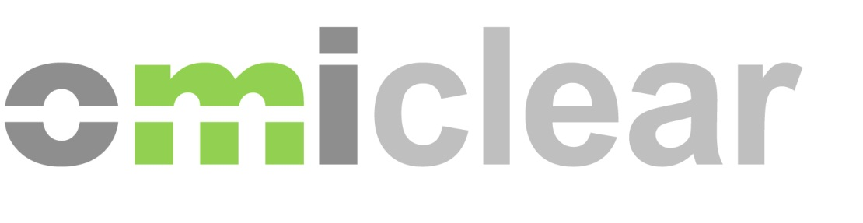
Iberian Energy Derivatives Market - Operational Training Course

Registration Form

Spanish session: 16th and 17th of March (10:00 – 13:00 CET)
Portuguese session: 18th and 19th of May (10:00 – 13:00 GMT)
Sessions (choose one):

Price: 500 € (+VAT)
After receiving the registration form dully filled, we will send an email with the invoice and payment instructions with bank details. Registrations are only confirmed once the required payment has been received.

Participant:
Name
Company
E-mail

Invoice details:
Company
Address
Tax Number
Telephone Number
Contact Person

